## Ada Lovelace

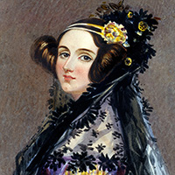

Ada Lovelace was an English mathematician in the mid-1800s whose work is considered to be the first written instructions for computer programming.

Lovelace’s immersion in both fields began with her parents: Romanticism’s playboy poet Lord Byron and his “Princess of the Parallelogram,” a prim and proper product of the Industrial Revolution named Annabella Milbanke. As hinted by Lord Bryon arriving several days late to his own wedding, their marriage would not last. Although divorce was heavily stigmatized in England’s Regency Era, Byron’s incest with his half sister was even more taboo. Lovelace, then just four months old, would never know her father.

Fearing that her daughter might inherit Lord Byron’s manic tendencies, Annabella imposed on Ada a strict diet of mathematics and science. Lovelace’s tutors believed that, had she been a man, there would have been “potential to become an original mathematical investigator, perhaps of first-rate eminence.” Indeed, Ada’s processing power was reportedly so great she suffered from headaches that impaired her vision.

Although many men of the time feared “the very great tension of mind which [sophisticated mathematics] requires is beyond a woman’s physical power,” Lovelace viewed things differently, writing: “Nothing but a very close and intense application to subjects of a scientific nature now seems at all to keep my imagination from running wild, or to stop the voice which seems to be left in my mind.”

At 17, Lovelace became friends with inventor and father of the computer, Charles Babbage. Babbage was best known for designing the difference engine, a computer meant to perform mathematical calculations. He also designed its successor, the analytical engine which was supposed to carry out more complex calculations.

At 19, marriage led to three children in four years. At 26, encouraged by her husband, Lovelace returned to assisting her friend and mentor Charles Babbage, known as the father of the computer.

Over time, Babbage became so impressed with Lovelace’s analytical skills that he called her the “Enchantress of Number.” He later asked Lovelace to translate an article written by an Italian mathematician about the analytical engine from French to English. While translating the article, she added her own notes describing how to write code for the device to handle letters, symbols and numbers.

“The Analytical Engine has no pretentions whatever to *originate* anything,” she wrote in one of those footnotes. “It can do whatever we *know how to order it*to perform. It can *follow* analysis; but it has no power of *anticipating* any analytical relations or truths. Its province is to assist us in making *available* what we are already acquainted with.”

Thanks to those notes on the engine, Lovelace is now widely recognized as the first computer programmer.

Ada Lovelace is considered to be the founder of scientific computing and the first computer programmer. Her algorithm — which history has come to know as the first one designed for a machine to carry out. Lovelace would sadly not see built during her lifetime. Lovelace passed away in 1852, but her previously little-known work and "poetical" approach to science has broken through to inspire present-day young women interested in computer programming.

Although she earned little public recognition during her lifetime, Ada Lovelace is now considered a pioneer and prophet of the computer age. In the first entry to his book *Innovators*, Walter Isaacson wrote: “Like Steve Jobs, [Ada Lovelace] stands at the intersection of arts and technology.”

Today, Lovelace’s legacy lives on as the world’s first computer programmer. Her work with Babbage and her mathematical mind not only gave us the first language of code, but also the method of looping, which is a series of instructions that continually repeats until a certain condition is reached. The looping process is still in use by programmers today.

[**Evelyn Boyd Granville** (1924-)](http://insights.dice.com/2016/03/14/10-famous-women-in-tech-history/6/)  
Race, Space, & Education Advocacy

Growing up in Washington, D.C. during the Great Depression, Evelyne Boyd Granville perpetually saw her glass as half-full. “I was aware that segregation placed many limitations on Negros,” she wrote. “However, daily one came into contact with Negroes who had made a place for themselves in society…”

Granville’s daily contact with such role models began at Dunbar High School, where highly educated teachers (white and black) instilled a belief in Granville that, regardless of race and gender, all deserved access to knowledge. “We accepted education as the means to rise above the limitations that a prejudiced society endeavored to place upon us.”

Pinched pennies, financial aid, and academic scholarship made her continued education possible. Granville attended Smith College and then Yale for her Ph.D, becoming just the second African American women to receive a mathematics doctorate at any American University.

After a few years of teaching at Fisk University, an all-black college in Nashville, Granville began her professional career performing real-time’ calculations for satellite launchings. She studied rocket trajectories and methods of orbit computation as a part of the U.S. involvement in the space race. In 1967, Granville returned to the classroom, where she began an impressive 30-year commitment to education advocacy.

[**Sister Mary Kenneth Keller** (1913-1985)](http://insights.dice.com/2016/03/14/10-famous-women-in-tech-history/7/)  
First Female Computer Science PhD

The first woman to receive a Ph.D in Computer Science was a nun: Mary Kenneth Keller entered the “Sister of Charity” in 1932, professing her vows in 1940.

Keller received her B.S./M.S. Mathematics from DePaul University in Chicago and briefly studied at Dartmouth, breaking the “men-only” rule. While there, Keller played a significant role developing a key computer language: Beginner’s All-Puprose Symbolic Instruction Code, or BASIC.

Keller understood that the world was “having an information explosion… and information is of no use unless it’s available.” Thanks to BASIC, writing custom software was no longer restricted to mathematicians and scientists. Her contribution made computer use much more accessible to a broader portion of the population.

Keller returned to the Midwest and, in 1965, received her PhD from the University of Wisconsin. Clarke College in Dubuque, Iowa hired Keller to create and chair their Computer Science Department, where she continued to grow and share her knowledge for 20 years

[**Susan Kare** (1954-)](http://insights.dice.com/2016/03/14/10-famous-women-in-tech-history/8/)  
The Apple Icon

Although our next pioneer briefly worked for Microsoft, Susan Kare is best known for her work with Bill Gate’s nemesis, Steve Jobs.

Kare followed dreams of a career in the fine arts to San Francisco. A chance encounter with an old high school friend landed her an interview with Apple. Steve Jobs, inspired by Xerox’s graphical user interface (GUI), was on the hunt for an artist who could design Macintosh’s icons. She got the job. “The morale is to have confidence in your skill mix,” she later said. “Because I certainly didn’t have a computer background.”

Using a pad of graph paper, Kare designed icons that were simple, elegant, and playful. The original designs were just 32 x 32 pixels. Kare is also responsible for developing the command (“Apple”) key as a stylized castle seen from above.

As part of her Apple work, Kare created the typeface Chicago, used in the first four generations of the iPod. To keep the lettering smooth and seamless, all lines were purposefully made horizontal, vertical, or on a 45-degree angle. That sort of attention to detail has continued to define Apple to this day.

[**Carol Shaw** (1955-)](http://insights.dice.com/2016/03/14/10-famous-women-in-tech-history/9/)  
Atari Game Developer

Carol Shaw was born and raised in Palo Alto, CA. Always excellent at math, it wasn’t until she inherited her brothers’ model railroad that Shaw began tinkering with electronics: “I actually designed some circuitry … with some transistors and stuff that would turn on the signal light for various blocks showing there was a train up ahead.”

Fresh out of Berkeley’s Computer Science graduate program, Shaw accepted a position at game-maker Atari in the late 1970s. Wearing thick-rimmed glasses and flannel, she biked 10 miles each way to design and program video games.

Eventually landing at Activision, Shaw programmed one of the Atari’s best-known shooter games, River Raid. For the first time, gamers could experience an inordinate amount of non-random, repeating terrain despite constrictive memory limits. River Raid was the first game that allowed the shooter to accelerate and slow down all over the screen.

Shaw’s work as a pioneer game designer has made her a legend to two generations of tech pros and gamers.

[**Janese Swanson**(1958-)](http://insights.dice.com/2016/03/14/10-famous-women-in-tech-history/10/)  
Easy was never an option for Janese Swanson. After her father died in Vietnam, she began helping her mother clean houses for extra cash. One day, while cleaning a wealthy doctor’s home in La Jolla, CA, Swanson shared a dream of becoming a doctor herself. The doctor’s wife advised: “It will be easier for you if you marry a doctor.”

At age 15, she fibbed her date of birth and started slinging televisions at Sears. Many years later, Swanson would use her electronic sales experience as manager of the computer and technology department at a small store called My Child’s Destiny. Interested in the nexus of technology and children education, she received Computers in Education Certificate from Berkeley, all while raising her daughter.

In 1988, Swanson began working for Broderbund Software Company, developing games for kids such as, “Where in the World is Carmen Sandiego?” However, she struggled there as “[we women] earned far less than there male colleagues… had to raise hands to get a word in [at meetings] … and always had a hard time getting men to focus on what we were saying rather than our legs and breasts.” She quit, got her Ph.D from San Francisco State, and, in 1995, started her own toy company, Girl Tech.

Swanson initially struggled to find investors and vendors. “For two years after I founded the company, toy store buyers would say, ‘Can you make it pink’ [or] ‘Can you make it for boys?’ And I would say, ‘No, this is what girls like to play with.’”

It wasn’t easy but, in 1998, Swanson sold Girl Tech to Radica Games Limited for $6 million. She remained with the company for 2 years as Vice President.

**Ana Roqué de Duprey**

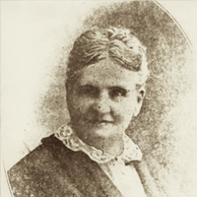

Ana Roqué de Duprey was born in Puerto Rico in 1853. She started a school in her home at age 13 and wrote a geography textbook for her students, which was later adopted by the Department of Education of Puerto Rico. Roqué had a passion for astronomy and education, founding several girls-only schools as well as the College of Mayagüez, which later became the Mayagüez Campus of the University of Puerto Rico. Roqué wrote the Botany of the Antilles, the most comprehensive study of flora in the Caribbean at the beginning of the 20th century, and was also instrumental in the fight for the Puerto Rican woman’s right to vote.

## Lillian Gilbreth

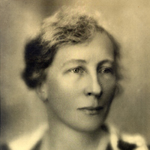

Lillian Moller Gilbreth was an American psychologist and industrial engineer at the turn of the 20th century. She was an expert in efficiency and organizational psychology, the principles of which she applied not only as a management consultant for major corporations, but also to her household of twelve children, as chronicled in the book Cheaper by the Dozen. Her long list of firsts includes first female commencement speaker at the University of California, first female engineering professor at Purdue, and first woman elected to the National Academy of Engineering.

[**Radia Perlman** (1951-)](http://insights.dice.com/2016/03/14/10-famous-women-in-tech-history/11/)  
Who’s going to break the news to Al Gore? Radia Perlman, often described as the ‘Mother of the Internet,’ insists that, “The Internet was not invented by any individual.”

Perlman did, however, create the algorithm behind the Spanning Tree Protocol (STP), which is an essential part of the Internet’s underlying foundation.

As a child, Perlman put a lot of pressure on herself to get straight A’s. Although she excelled at all subjects, she naturally gravitated to math and science because she could control her grades by just knowing the right answer. Although her mother was a mathematician/computer programmer, similar to the women of ENIAC, the two rarely spoke about programming.

Perlman went on to MIT, just one of handful of females in her class (~50 of 1,000 students). In 2000, Perlman published her textbook “Interconnections,” greatly simplifying network routing and bridging. “My book created order,” she later said. “It was easy to understand while being conceptually thought-provoking, and a large part of the technology described was stuff I’d invented.”

Despite her success, Perlman keeps a level head and credits others equally for her success: “In engineering, the point is to get the job done, and people are happy to help. You should be generous with credit, and you should be happy to help others.

## Ruth Rogan Benerito

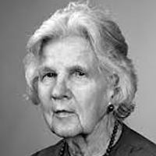

Ruth Rogan Benerito was an American chemist and pioneer in bioproducts. Benerito is credited with saving the cotton industry in post-WWII America through her discovery of a process to produce wrinkle-free, stain-free, and flame-resistant cotton fabrics. In addition to this work, Benerito also developed a method to harvest fats from seeds for use in intravenous feeding of medical patients. This system became the foundation for the system we use today. After retiring from the USDA and teaching university courses for an additional eleven years, Benerito received the Lemelson-MIT Lifetime Achievement Award both for her contributions to the textile industry and her commitment to education.

## Edith Clarke

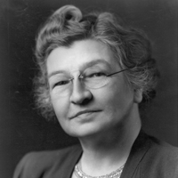

Edith Clarke was a pioneering electrical engineer at the turn of the 20th century. She worked as a “computer,” someone who performed difficult mathematical calculations before modern-day computers and calculators were invented. Clarke struggled to find work as a female engineer instead of the ‘usual’ jobs allowed for women of her time, but became the first professionally employed female electrical engineer in the United States in 1922. She paved the way for women in STEM and engineering and was inducted into the National Inventors Hall of Fame in 2015.

No matter the obstacle, Edith Clarke knew how to take charge of her own destiny: “I had always wanted to be an engineer, but felt that women were not supposed to be doing things like studying engineering.”

By no means, however, was Clarke’s rise simple and easy. Orphaned at age 12, she came of age in a Maryland boarding school. At 18, she received a small inheritance which took her through Vassar College, then Yale’s all-women sister institution; she graduated in 1908. After teaching gigs in San Francisco and Wisconsin, Clarke returned to the field full-time as manager of an all-female team of “human computers” at AT&T. She had reached the ceiling for women in electrical engineering.

Determined to continue her career doing what “women were not supposed to be doing,” the pioneering powerhouse next enrolled at MIT and became that institution’s first woman to earn an M.S. in electrical engineering. But even with such a degree, no company would hire female engineers. In response, Clarke left the United States to teach physics at Istanbul’s Women’s College. Again, she couldn’t stay out of the field, returning to the United States as a “human computer” for General Electric.

At GE, Edith Clarke created and patentedThe Clarke Calculator*,* a graphical device that solved equations used to send power through electrical transmission lines longer than 250 meters. Her massive contribution to transcontinental telephone communication silenced skeptics; in 1922, at 38, Edith Clarke became the first professional female electrical engineer.

## Mollie Orshansky

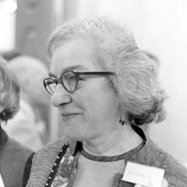

Mollie Orshansky was a food economist and statistician whose work on poverty thresholds pioneered the way the U.S. Government defines poverty. By using the cost of the cheapest nutritionally adequate diet to calculate a cost of living expense for families of various sizes, Orshansky developed guidelines which eventually became the federal government’s official statistical definition of poverty. Her work provided a way to assess the impact of new policies on poor populations, which to this day remains a standard measure of new policies, demonstrating the enduring impact of her work on American public policy.

## Mary Engle Pennington

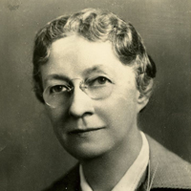

Mary Engle Pennington was an American chemist at the turn of the 20th century. At a time when few women attended college, Pennington completed her PhD and went on to work as a bacteriological chemist at the U.S. Department of Agriculture. Shortly after arriving at the USDA, Pennington became chief of the newly established Food Research Laboratory. During her 40-year career at the USDA, Pennington’s pioneering research on sanitary methods of processing, storing, and shipping food led to achievements such as the first standards for milk safety as well as universally accepted standards for the refrigeration of food products.

## Ellen Ochoa

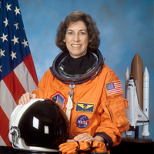

In 1993, Dr. Ellen Ochoa became the first Hispanic woman to go to space when she served on a nine-day mission aboard the space shuttle Discovery. She has flown in space four times, logging nearly 1,000 hours in orbit. Prior to her astronaut career, she was a research engineer and inventor, with three patents for optical systems. Ochoa is also the first Hispanic (and second female) to be named director of NASA’s Johnson Space Center.

## Calutron Girls

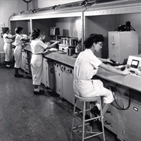

Isolating enriched uranium was one of the most difficult aspects of the Manhattan Project, which produced the first nuclear bombs during World War II. Wartime labor shortages led the Tennessee Eastman Company to recruit young women, who were mostly recent high school graduates, to operate the calutrons that used electromagnetic separation to isolate uranium. Despite being kept in the dark on the specifics of the project, the “Calutron Girls” proved to be highly adept at operating the instruments and optimizing uranium production, achieving better rates for production than the male scientists they worked with.

## Virginia Holsinger

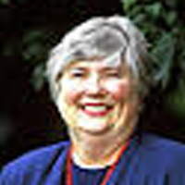

Virginia H. Holsinger was an American chemist known for her research on dairy products and food security issues. Holsinger developed a nutritious and shelf-stable whey and soy drink mixture that is distributed internationally by food donation programs as a substitute for milk. She also created a grain blend that can be mixed with water to provide food for victims of famine, drought, and war. Additionally, her work on the lactase enzyme formed the basis for commercial products to make milk digestible by lactose-intolerant people. Through these discoveries, Holsinger’s work has had a major impact on worldwide public health.

## Grace Hopper

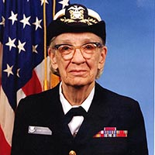

[Rear Admiral Grace Murray Hopper](http://www.history.navy.mil/bios/hopper_grace.htm) was at the forefront of computer and programming language development from the 1930s through the 1980s. One of the crowning achievements of her 44-year career was the development of computer languages written in English, rather than mathematical notation — most notably, the common business computing language known as COBOL, which is still in use today.  Hopper's legacy is still honored by the annual [Grace Hopper Celebration of Women in Computing Conference](http://gracehopper.org/about/).

Grace Hopper was a computer scientist, Yale Ph.D, and United States Navy Rear Admiral who also—on top of everything else—helped pioneer computer programming. “Humans are allergic to change,” she once said. “They love to say, ‘We’ve always done it this way.’ I try to fight that. That’s why I have a clock on my wall that runs counter-clockwise.”

In 1945, after 10 years of teaching, Hopper joined a new volunteer branch of the Navy known as WAVES (Women Accepted for Volunteer Emergency Service). At just 105 pounds, she was 15 pounds below that Navy minimum weight and had to receive a special exemption.

During her illustrious career, Hopper worked on UNIVAC I, the first commercial computer produced in the U.S., and created the first compiler. She is also credited with coining the term “computer bug” when she found a real moth inside the massive UNIVAC I.

If that wasn’t enough, Hopper also invented FLOW-MATIC, the first English-like data processing language, which helped spark the development of COBOL, which eventually became the Navy’s standard operating language.

Late-night show host David Letterman once asked Hopper, “You know you’re the Queen of Software, right?”

She replied: “More or less.”

## Katherine Johnson

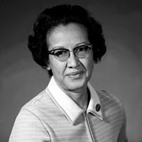

Katherine Johnson, an African-American space scientist and mathematician, is a leading figure in American space history and has made enormous contributions to America’s aeronautics and space programs by her incorporation of computing tools. She played a huge role in calculating key trajectories in the Space Race -- calculating the trajectory for Alan Shepard, the first American in space, as well as for the 1969 Apollo 11 flight to the moon. Johnson is now retired, and continues to encourage students to pursue careers in science and technology fields.

## Rachel Carson

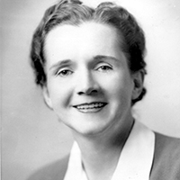

Rachel Carson was a marine biologist and environmentalist — whose groundbreaking book, *Silent Spring*, has been credited as the catalyst for the modern environmental movement. Carson passed away in 1964, but her work has been credited with the legacy of “awakening the concern of Americans for the environment.”

## Maria Klawe

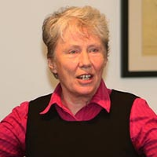

Despite growing up as a self-described outcast, Maria Klawe pursed her passion for technology and became a prominent computer scientist. Klawe is now the first female president of Harvey Mudd College and works hard to ignite passion about STEM fields amongst diverse groups. During her tenure at Harvey Mudd College, her work has helped support the Computer Science faculty's ability to innovate, and has raised the percentage of women majoring in computer science from less than 15 percent to more than 40 percent today.

## Lydia Villa-Komaroff

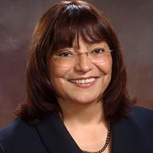

[Lydia Villa-Komaroff is considered to be a trailblazer in the field of molecular biology](http://nihrecord.nih.gov/newsletters/2013/05_10_2013/story2.htm). She faced many adversities she faced throughout her lifetime — at one point, an advisor told her that women did not belong in chemistry, fortuitously inspiring her to switch her major to biology — but she pursued her passion in spite of opposition. In 1978, Villa-Komaroff made waves with a published paper detailing her most notable discovery — that bacteria could be engineered to produce human insulin. She currently serves as the Chief Scientific Officer (CSO) at Cytonome/ST.

**Margaret Hamilton (1936-present)  [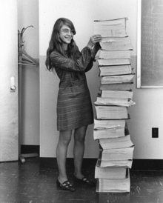](http://www.codingdojo.com/blog/wp-content/uploads/Margaret_Hamilton.gif)**

Margaret Hamilton, an American computer scientist, systems engineer and business owner, led the team that developed the on-board software for the Apollo Moon missions.

In the 1960s Hamilton took a job with MIT as a developer on the Semi-Automatic Ground Environment (SAGE) project. SAGE was a system of large computers and networking equipment that pulled data from radars to produce a single image of the airspace over a wide area. This technology was eventually used by the military for anti-aircraft air defense against the Soviets during the Cold War. Hamilton’s participation in this project catapulted her into her longstanding career as a computer programmer.

Hamilton then joined Charles Stark Draper Laboratory at MIT, where she began working as the lead software designer for the Apollo space mission. During the most critical moments of the Apollo 11 mission, it was Hamilton’s priority alarm display that helped decide whether an alert the astronauts received just before they were to land on the Moon meant they should abort their mission. Thanks to Hamilton’s system, the NASA team was able to see that the alert was nothing critical, and the landing went ahead.

President Obama gave Hamilton the Presidential Medal of Freedom in 2016 to recognize her work saying she encapsulated the “American spirit of discovery that exists in every little girl and little boy.”

## Sally Ride

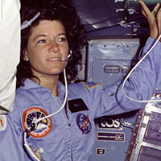

On June 18, 1983, Sally Ride transformed history when she became the first American woman to fly into space. After her second shuttle flight, Ride decided to retire from NASA and pursue her passion for education by inspiring young people. As a result, she founded [Sally Ride Science](http://www.sallyridescience.com/), an organization dedicated to supporting students interested in STEM. Ride passed away in 2012, but her work continues to inspire young women across the country.

## Barbara McClintock

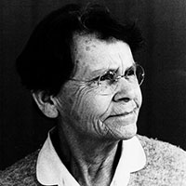

[Barbara McClintock was an American geneticist](http://www.nsf.gov/news/special_reports/medalofscience50/mcclintock.jsp) and is still considered to be one of the world’s most prestigious cytogeneticists. In 1983, McClintock won the Nobel Prize in Physiology for her discovery of the “jumping gene” or the ability of genes to change position on the chromosome. McClintock passed away in 1992, but [her publications still influence](http://profiles.nlm.nih.gov/LL/) geneticists across the world.

## The Mercury 13

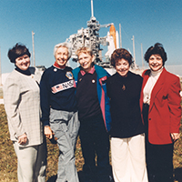

[The Mercury 13, also sometimes known as the “Members of the First Lady Astronaut Trainees” (FLATs)](http://www.nasa.gov/multimedia/imagegallery/image_feature_691.html#.VIiriOZdUkc), were a group of women who participated in training to become astronauts for the country's first human spaceflight program in the early 1960s. FLATs was never an official NASA program, and was unfortunately eventually discontinued, but the commitment and determination of these women to get into space has been credited with paving the way for such astronauts as Mae Jemison, the first African-American woman in space.

## The ENIAC Programmers

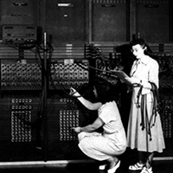

As part of a secret World War Two project, six young women programmed the first all-electronic programmable computer. When the project was eventually introduced to the public in 1946, the women were never introduced or credited for their hard work -- both because computer science was not well understood as an emerging field, and because the public's focus was on the machine itself. [Since then, the ENIAC Programmers Project](http://eniacprogrammers.org/) has worked hard to preserve and tell the stories of these six women. In 1945–46, [Jean Bartik and five other women developed and codified many of the foundations of software programming](http://www.witi.com/center/witimuseum/halloffame/298369/ENIAC-Programmers-Kathleen-McNulty,-Mauchly-Antonelli,-Jean-Jennings-Bartik,-Frances-Synder-Holber-Marlyn-Wescoff-Meltzer,-Frances-Bilas-Spence-and-Ruth-Lichterman-Teitelbaum/) while working on ENIAC. The six women, whose software work was crucial to its operation and success, were not invited to the dinner celebration for the completion of ENIAC.

The day before it debuted, the world’s first general-purpose computer failed to work. It was up to seven women to stay late and make the beast, dubbed ENIAC (Electronic Numerical Integrator and Computer) operational. They were:

* Betty Jean Jennings Bartik,
* Kathleen McNulty,
* Mauchly Antonelli,
* Ruth Lichterman Teitelbaum,
* Frances Bilas Spence,
* Marlyn Wescoff Meltzer,
* Frances Snyder Holberton

The system was neither small nor simple, weighing in at 30 tons and taking up a 1,500-square-foot basement. It came equipped with 18,000 vacuum tubes, 70,000 resistors, 10,000 capacitors, and 5 million hand-soldered joints. Considering its supposed aptitude with calculating ballistics trajectories, the need for it to work was great—the United States was mired deep in World War II.

“People never recognized, they never acted as though we knew what we were doing,” Betty Bartik would say later. “I mean, we were in a lot of pictures.”

It would take a few decades before these female computing pioneers received due recognition. In 1997, they were inducted into the Women in Technology International (WITI) Hall of Fame. In 2014, Walter Isaacson featured them in *Innovators* with the likes of Steve Jobs and Nikola Tesla. And last year saw the release of a documentary called the “Eniac Programmers Project,” which detailed how these women figured out how to program the machine.

After the war, many of the women of ENIAC went on to help “Amazing Grace” Hopper develop UNIVAC, the world’s first commercial computer.

## Rosalind Franklin

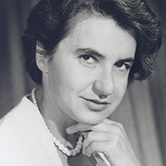

Rosalind Franklin was a British chemist and crystallographer, best known for her research that was essential to elucidating the structure of DNA. During her lifetime, Franklin was not credited for her key role, but years later she is recognized as providing a pivotal piece of the DNA story. Franklin spent the last five years of her life studying the structure of plant viruses and passed away in 1958.

[Betty Holberton](http://www.nytimes.com/2001/12/17/business/frances-e-holberton-84-early-computer-programmer.html). She goes on to basically head up computing at the U.S. Census Bureau. [Stephanie Shirley](https://www.ted.com/speakers/dame_stephanie_steve_shirley), a women in the U.K. who basically founds a software company devoted to hiring other women. She’s one of the richest women in the U.K. — probably one of the first software billionaires — and for most of her career she went by Steve because she was concerned about sexism. [Margaret Hamilton](http://time.com/3948364/moon-landing-apollo-11-margaret-hamilton/), a programmer at NASA, whom President Obama awarded the Presidential Medal of Freedom. [Adele Goldberg](http://www.ithistory.org/honor-roll/dr-adele-goldberg), she’s at [Xerox](http://fortune.com/fortune500/xerox/) Park. [Jean Sammet](https://www.nytimes.com/2017/06/04/technology/obituary-jean-sammet-software-designer-cobol.html?_r=0), she’s one of the key inventors of the programming language COBOL.

Grete Hermann, from making significant contributions to their fields. Her doctor thesis [The Question of Finitely Many Steps in Polynomial Ideal Theory](http://www.risc.jku.at/Groebner-Bases-Bibliography/gbbib_files/publication_775.pdf), published in 1926, established algorithms for abstract algebra and laid the groundwork for modern computer algebra.

With World War II came two factors that would bring an enormous influx of technical opportunities for women: The draft and the urgent need for advancements in technology.

[Several hundred women worked](http://www.atomicheritage.org/article/women-scientists-manhattan-project) as engineers and technicians on the Manhattan Project, though due to the secrecy of the project, many of their contributions to science and technology (as well as those of their male counterparts) would go unrecognized until after the war.

During World War II, in 1942, [Hedy Lamarr invents the frequency-hopping technology](https://www.theguardian.com/theguardian/shortcuts/2011/dec/04/hedy-lamarr-wifi) that would later allow the invention of wireless signals like Wi-Fi and Bluetooth.

Moving into the post-war era and the 1960’s, software engineering was considered “women’s work” because it was thought of as clerical. Hardware was the difficult job, i.e. “for men”. Cosmopolitan famously ran a 1967 issue about “The Computer Girls,” with Admiral Hopper saying women are “naturals” at computer programming. (By “naturals” Hopper wasn’t referring to biology, it should be noted, but to the responsibilities women were socialized in, such as planning a dinner and having everything be ready at the appropriate time.)

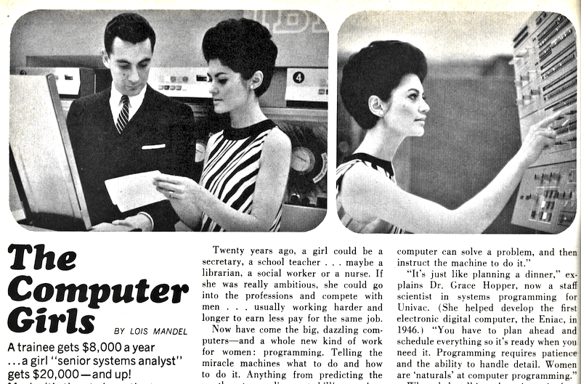

Partial scan of the 1967 Cosmopolitan article on The Computer Girls.

what about Wendy Hall (Microcosm)? Brenda Laurel (Art of Human-Computer Interface Design)?

<https://obamawhitehouse.archives.gov/node/311241>

further reading

<https://hackernoon.com/a-brief-history-of-women-in-computing-e7253ac24306>

<https://en.wikipedia.org/wiki/Women_in_computing>

<https://www.slideshare.net/sadukie/history-of-women-in-tech-trivia>

<http://blog.honeypot.io/the-history-of-women-in-technology/>

<http://www.newinc.org/news-posts/women-art-tech-list-2017>

<https://www.dailydot.com/via/women-who-changed-tech-industry-forever/>